SQL Schemas

🌟 Definition
# Source: AI Source: Provided by: [Data Path: Persons Table -> ID Column: 1, Name_En Column: Motasem Essam] -> From: [ChatGPT] on [6/11/2026]
A SQL Schema is a logical container inside a database that organizes and groups related database objects such as tables, views, indexes, stored procedures, functions, and sequences.
Schemas help organize large databases, improve security, and avoid naming conflicts between objects.
Think of a schema as a folder inside a database.

🎯 Purpose
# Source: AI Source: Provided by: [Data Path: Persons Table -> ID Column: 1, Name_En Column: Motasem Essam] -> From: [ChatGPT] on [6/11/2026]
SQL Schemas are used to:
- Organize database objects
- Group related tables and other objects
- Improve database security
- Control user permissions
- Prevent object name conflicts
- Simplify database management

🧠 Simple Example
# Source: AI Source: Provided by: [Data Path: Persons Table -> ID Column: 1, Name_En Column: Motasem Essam] -> From: [ChatGPT] on [6/11/2026]
Imagine a company database.
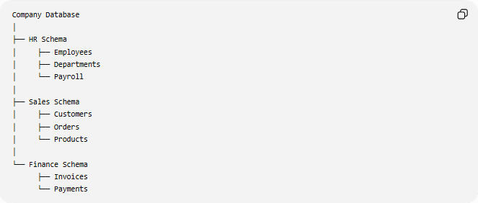
Company Database
│
├── HR Schema
│ ├── Employees
│ ├── Departments
│ └── Payroll
│
├── Sales Schema
│ ├── Customers
│ ├── Orders
│ └── Products
│
└── Finance Schema
├── Invoices
└── Payments
Each department stores its own database objects inside its own schema.

📝 Syntax
# Source: AI Source: Provided by: [Data Path: Persons Table -> ID Column: 1, Name_En Column: Motasem Essam] -> From: [ChatGPT] on [6/11/2026]
Create a Schema
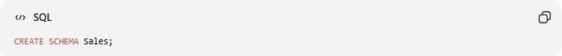
CREATE SCHEMA Sales;

Create a Table Inside a Schema
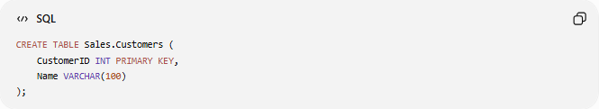
CREATE TABLE Sales.Customers (
CustomerID INT PRIMARY KEY,
Name VARCHAR(100)
);

Query a Table
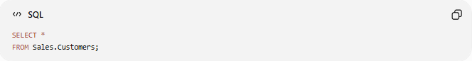
SELECT *
FROM Sales.Customers;

🔢 Components of a Schema
# Source: AI Source: Provided by: [Data Path: Persons Table -> ID Column: 1, Name_En Column: Motasem Essam] -> From: [ChatGPT] on [6/11/2026]
A schema may contain:
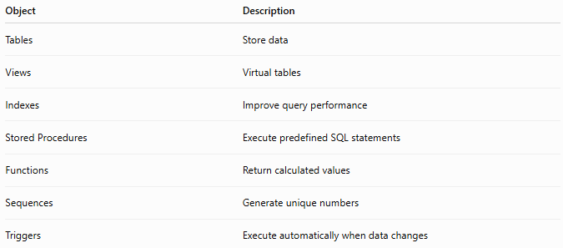
Object | Description
Tables | Store data
Views | Virtual tables
Indexes | Improve query performance
Stored Procedures | Execute predefined SQL statements
Functions | Return calculated values
Sequences | Generate unique numbers
Triggers | Execute automatically when data changes

📚 Schema vs Database
# Source: AI Source: Provided by: [Data Path: Persons Table -> ID Column: 1, Name_En Column: Motasem Essam] -> From: [ChatGPT] on [6/11/2026]
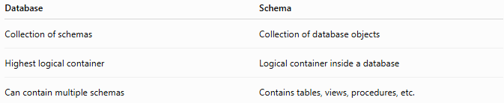
Database | Schema
Collection of schemas | Collection of database objects
Highest logical container | Logical container inside a database
Can contain multiple schemas | Contains tables, views, procedures, etc.

Example
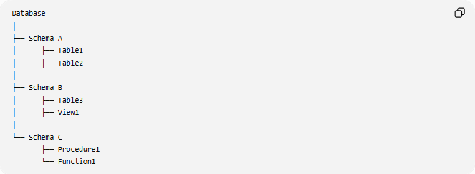
Database
│
├── Schema A
│ ├── Table1
│ ├── Table2
│
├── Schema B
│ ├── Table3
│ ├── View1
│
└── Schema C
├── Procedure1
└── Function1

📚 Creating Multiple Schemas
# Source: AI Source: Provided by: [Data Path: Persons Table -> ID Column: 1, Name_En Column: Motasem Essam] -> From: [ChatGPT] on [6/11/2026]
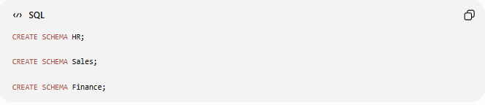
CREATE SCHEMA HR;

CREATE SCHEMA Sales;

CREATE SCHEMA Finance;

📚 Creating Tables in Different Schemas
# Source: AI Source: Provided by: [Data Path: Persons Table -> ID Column: 1, Name_En Column: Motasem Essam] -> From: [ChatGPT] on [6/11/2026]
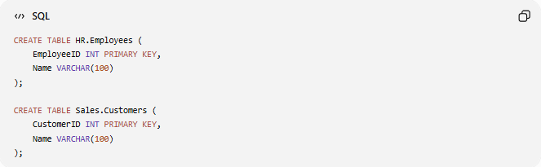
CREATE TABLE HR.Employees (
EmployeeID INT PRIMARY KEY,
Name VARCHAR(100)
);

CREATE TABLE Sales.Customers (
CustomerID INT PRIMARY KEY,
Name VARCHAR(100)
);

📚 Selecting Data
# Source: AI Source: Provided by: [Data Path: Persons Table -> ID Column: 1, Name_En Column: Motasem Essam] -> From: [ChatGPT] on [6/11/2026]
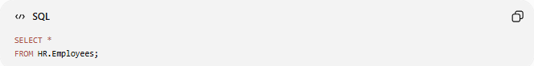
SELECT *
FROM HR.Employees;

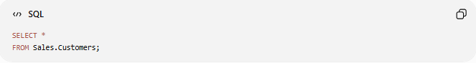
SELECT *
FROM Sales.Customers;

📚 Same Table Name in Different Schemas
# Source: AI Source: Provided by: [Data Path: Persons Table -> ID Column: 1, Name_En Column: Motasem Essam] -> From: [ChatGPT] on [6/11/2026]
Schemas allow objects with the same name to exist.
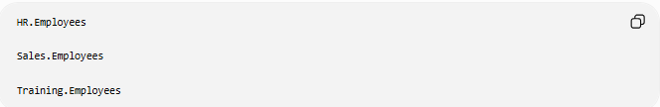
HR.Employees

Sales.Employees

Training.Employees
These are three different tables because they belong to different schemas.

🛠️ Complete Test Example

1️⃣ Create Schemas
# Source: AI Source: Provided by: [Data Path: Persons Table -> ID Column: 1, Name_En Column: Motasem Essam] -> From: [ChatGPT] on [6/11/2026]
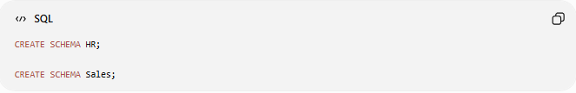
CREATE SCHEMA HR;

CREATE SCHEMA Sales;

2️⃣ Create Tables
# Source: AI Source: Provided by: [Data Path: Persons Table -> ID Column: 1, Name_En Column: Motasem Essam] -> From: [ChatGPT] on [6/11/2026]
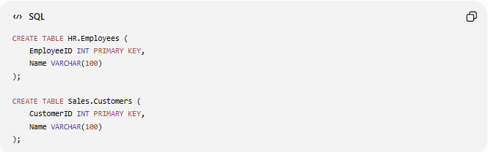
CREATE TABLE HR.Employees (
EmployeeID INT PRIMARY KEY,
Name VARCHAR(100)
);

CREATE TABLE Sales.Customers (
CustomerID INT PRIMARY KEY,
Name VARCHAR(100)
);

3️⃣ Insert Data
# Source: AI Source: Provided by: [Data Path: Persons Table -> ID Column: 1, Name_En Column: Motasem Essam] -> From: [ChatGPT] on [6/11/2026]
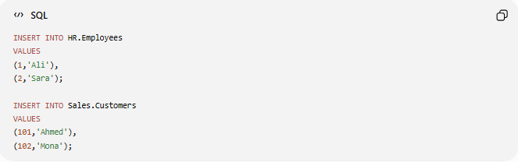
INSERT INTO HR.Employees
VALUES
(1,'Ali'),
(2,'Sara');

INSERT INTO Sales.Customers
VALUES
(101,'Ahmed'),
(102,'Mona');

4️⃣ Query Data
# Source: AI Source: Provided by: [Data Path: Persons Table -> ID Column: 1, Name_En Column: Motasem Essam] -> From: [ChatGPT] on [6/11/2026]
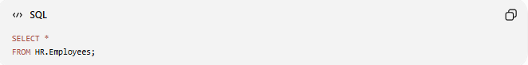
SELECT *
FROM HR.Employees;

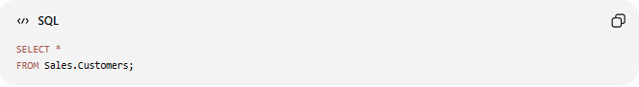
SELECT *
FROM Sales.Customers;

Real Example

basic command

1️⃣ Create Schemas
# Source: ScreenShot Source: Provided by: [Persons Table -> ID Column: 1, Name_En Column: Motasem Essam] -> Tool: [Automation Table -> ID Column: 16, Name_En Column: Screen Capture] -> From [Operating System: Wampserver64 -> phpmyadmin] on [6/11/2026]
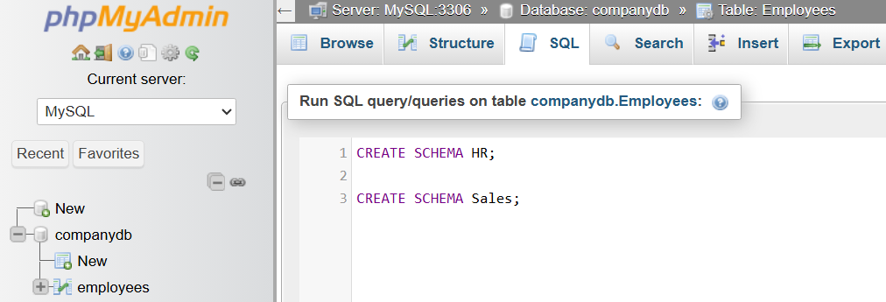
CREATE SCHEMA HR;

CREATE SCHEMA Sales;
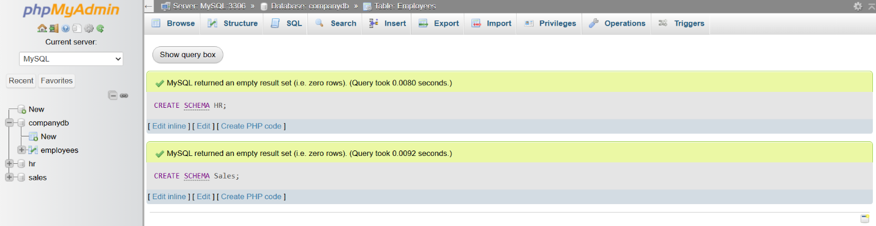

2️⃣ Create Tables
# Source: ScreenShot Source: Provided by: [Persons Table -> ID Column: 1, Name_En Column: Motasem Essam] -> Tool: [Automation Table -> ID Column: 16, Name_En Column: Screen Capture] -> From [Operating System: Wampserver64 -> phpmyadmin] on [6/11/2026]
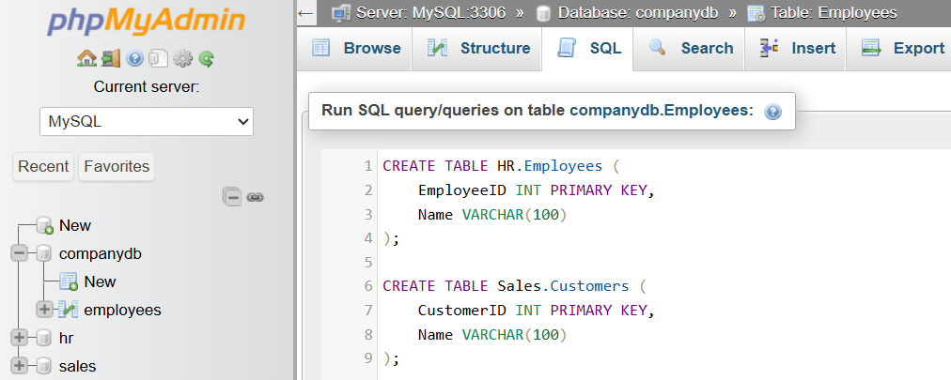
CREATE TABLE HR.Employees (
EmployeeID INT PRIMARY KEY,
Name VARCHAR(100)
);

CREATE TABLE Sales.Customers (
CustomerID INT PRIMARY KEY,
Name VARCHAR(100)
);
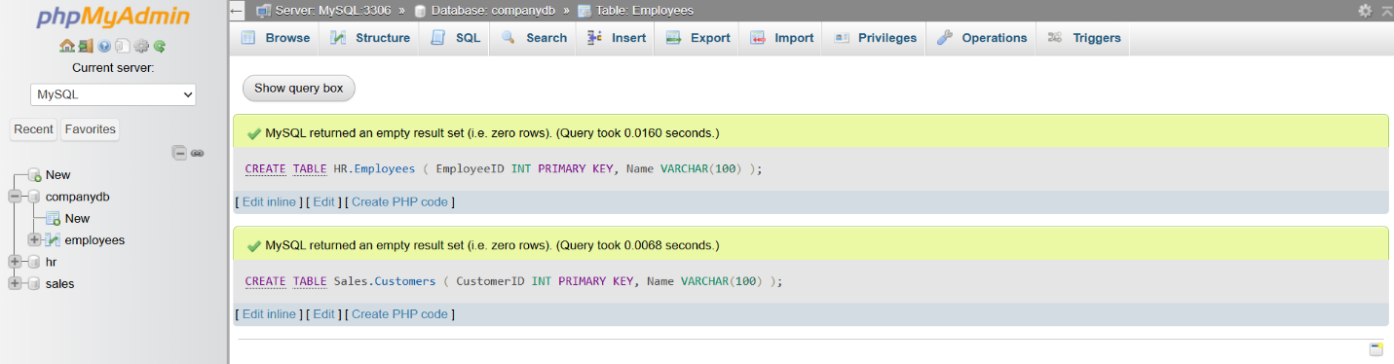

3️⃣ Insert Data
# Source: ScreenShot Source: Provided by: [Persons Table -> ID Column: 1, Name_En Column: Motasem Essam] -> Tool: [Automation Table -> ID Column: 16, Name_En Column: Screen Capture] -> From [Operating System: Wampserver64 -> phpmyadmin] on [6/11/2026]
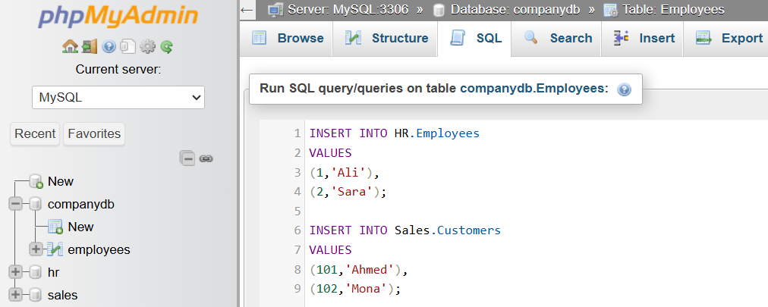
INSERT INTO HR.Employees
VALUES
(1,'Ali'),
(2,'Sara');

INSERT INTO Sales.Customers
VALUES
(101,'Ahmed'),
(102,'Mona');
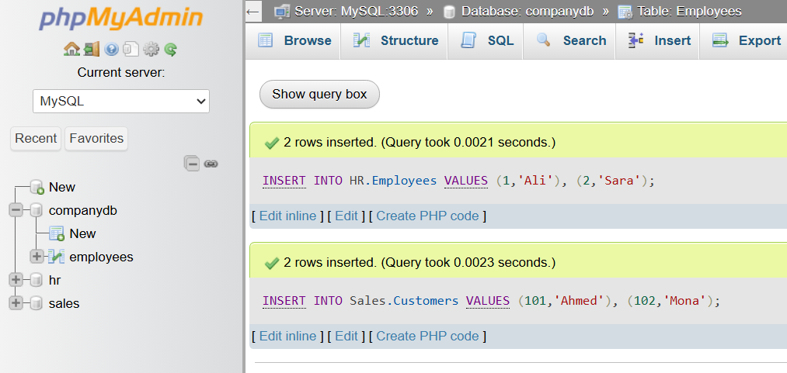

4️⃣ Query Data
# Source: ScreenShot Source: Provided by: [Persons Table -> ID Column: 1, Name_En Column: Motasem Essam] -> Tool: [Automation Table -> ID Column: 16, Name_En Column: Screen Capture] -> From [Operating System: Wampserver64 -> phpmyadmin] on [6/11/2026]
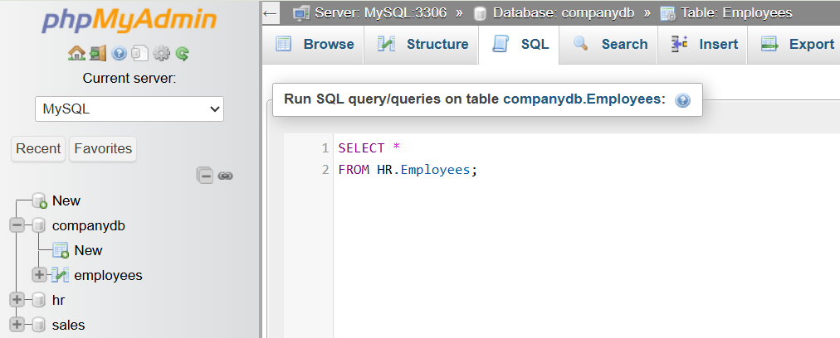
SELECT *
FROM HR.Employees;
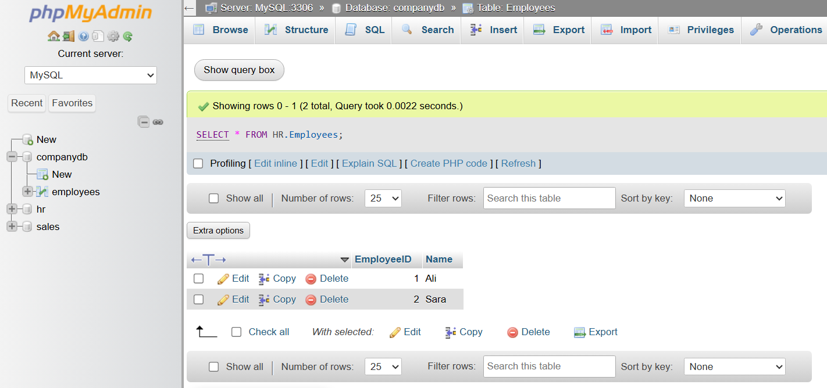

📊 Common SQL Schema Commands
# Source: AI Source: Provided by: [Data Path: Persons Table -> ID Column: 1, Name_En Column: Motasem Essam] -> From: [ChatGPT] on [6/11/2026]
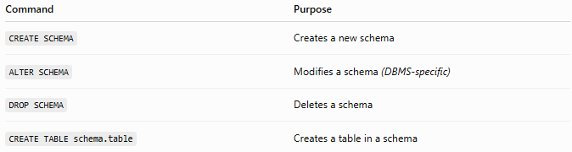
Command | Purpose
CREATE SCHEMA | Creates a new schema
ALTER SCHEMA | Modifies a schema (DBMS-specific)
DROP SCHEMA | Deletes a schema
CREATE TABLE schema.table | Creates a table in a schema

⚠️ Important Notes
# Source: AI Source: Provided by: [Data Path: Persons Table -> ID Column: 1, Name_En Column: Motasem Essam] -> From: [ChatGPT] on [6/11/2026]
- A schema is not a database.
- One database can contain multiple schemas.
- Object names are often written as:
schema_name.object_name
Example:
Sales.Customers
- Schemas improve security by allowing different permissions for different users.
- Support for schemas varies slightly between database systems.

🌍 Database Support
# Source: AI Source: Provided by: [Data Path: Persons Table -> ID Column: 1, Name_En Column: Motasem Essam] -> From: [ChatGPT] on [6/11/2026]
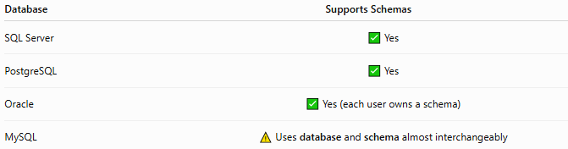
Database | Supports Schemas
SQL Server | ✅ Yes
PostgreSQL | ✅ Yes
Oracle | ✅ Yes (each user owns a schema)
MySQL | ⚠️ Uses database and schema almost interchangeably
Note: In MySQL, the terms DATABASE and SCHEMA are synonyms. For example, CREATE SCHEMA Sales; and CREATE DATABASE Sales; have the same effect.

🔢 SQL Schema Hierarchy
# Source: AI Source: Provided by: [Data Path: Persons Table -> ID Column: 1, Name_En Column: Motasem Essam] -> From: [ChatGPT] on [6/11/2026]
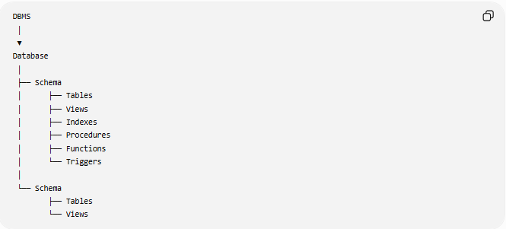
DBMS
│
▼
Database
│
├── Schema
│ ├── Tables
│ ├── Views
│ ├── Indexes
│ ├── Procedures
│ ├── Functions
│ └── Triggers
│
└── Schema
├── Tables
└── Views

🧠 Simple Analogy
# Source: AI Source: Provided by: [Data Path: Persons Table -> ID Column: 1, Name_En Column: Motasem Essam] -> From: [ChatGPT] on [6/11/2026]
Imagine a filing cabinet.
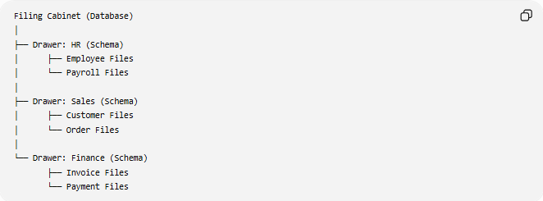
Filing Cabinet (Database)
│
├── Drawer: HR (Schema)
│ ├── Employee Files
│ └── Payroll Files
│
├── Drawer: Sales (Schema)
│ ├── Customer Files
│ └── Order Files
│
└── Drawer: Finance (Schema)
├── Invoice Files
└── Payment Files
- The database is the filing cabinet.
- Each schema is a drawer.
- The tables are folders inside each drawer.
This organization makes it easier to manage and locate related information.

🧭 Summary
# Source: AI Source: Provided by: [Data Path: Persons Table -> ID Column: 1, Name_En Column: Motasem Essam] -> From: [ChatGPT] on [6/11/2026]
A SQL Schema is a logical container within a database that organizes related database objects such as tables, views, indexes, stored procedures, and functions. Schemas improve organization, enhance security through permission management, and prevent naming conflicts. Most DBMSs support multiple schemas per database, while MySQL treats schemas and databases as equivalent concepts.

